Generative design

Computers have become the main part of everyday life, they help us solve math and financial problems, communicate with people around the world, help us find answers and good movies and books. When it comes to design, people are coming up with great ideas. Computers were just the tool for documenting the ideas. But what happens when computers evolve from passive command takers to generative partners? Nowadays computers can simulate and generate thousands of designs simply by defining design problems and inputting basic parameters, such as height, weight and material.
So what is Generative Design? Generative design is a form finding process that using artificial intelligence and algorithms generates countless design combinations, that fit pre-set design goals and parameters (such as weight, materials, size, strength, manufacturing methods, and cost constraints). Designer selects the most effective design from all iterations.
All the possibilities of programming and computer algorithms will eventually change the role of the designer. The question is how. How do the art and design change with using the deep learning machines and AI trained to solve design problems?

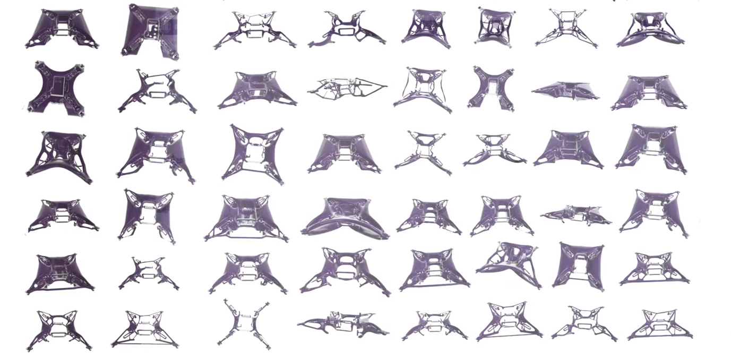

Pavle Vanja Konakovic

